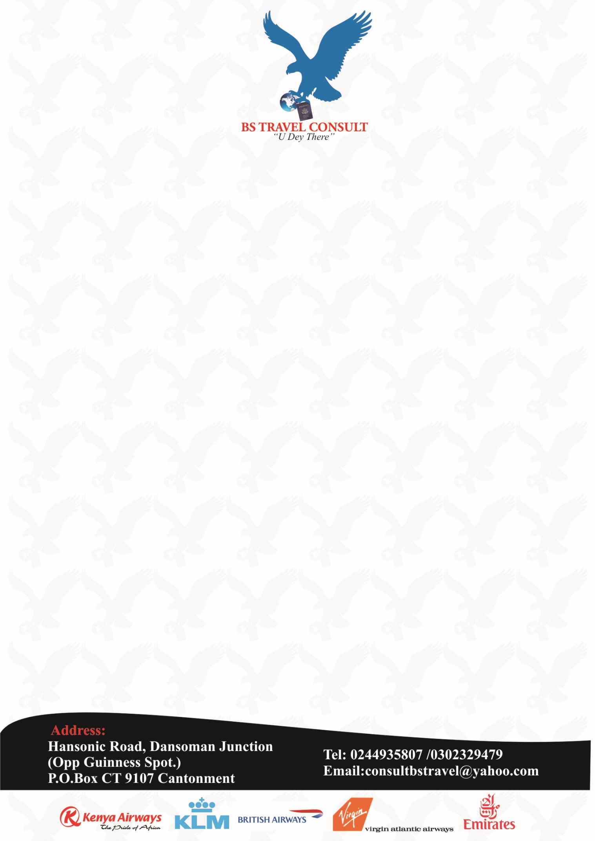

**TRAVEL MANAGEMENT PROPOSAL**

We wish to officially introduce ourselves to your Company.

We are a travel agency duly registered and incorporated in February 2013 and have since then been managing various travel requisites for individuals as well as companies.

Our CEO, Mr. Barnabas Sackey has been in the travel industry for over 16 years, working at the Kotoka International Airport, as well as been employed for various airlines until he established his own company BS TRAVEL CONSULT which is IATA approved.

During his many years operating in the travel industry, he has managed to gain a lot of experience, in addition to good relationships with immigration, as well as passport office. He also has sound knowledge in visa requirements for Ghana, alongside with other countries. This and much more he and our well trained staff, wish to bring to the table, to assist you with your travel needs.

We do believe, we will render the required service to your fullest satisfaction and at any time necessary.

We therefore though it prudent to react to your announcement, seeking for a qualified and experienced Travel Agent to handle your travel portfolio across Africa, Asia, Europe and the USA on page 30 of the Daily Graphic dated 28.04.2017.

We believe, even though being a small company, we can offer you better more convenient amenities, as we will be able to provide you with the specialized attention you require and cater to your unique travel requirements.

We have attached a very brief proposal, which we would like to discuss with you at your convenience in order to mold it to suit both our interests.

Thanking you for the possibility to introduce our selves and we hope to meet you to discuss our business co-operation.

Yours sincerely,

Barnabas Sackey

CEO